**Data Augmentation Techniques for Enhancing Deep Learning Performance and Revolutionizing AI Applications - InbuiltData**

Transforming Data into Actionable Insights for Smarter Decisions

Published Jun 27, 2024

In the rapidly evolving field of deep learning, the performance and generalization capabilities of models are critically dependent on the quality and quantity of data. One powerful strategy to maximize the potential of available data is through data augmentation. This newsletter will delve into various data augmentation techniques that can significantly enhance deep learning performance, enabling models to achieve higher accuracy and robustness.

At **[InbuiltData](https://in.linkedin.com/company/inbuiltdata?trk=article-ssr-frontend-pulse_little-mention" \t "_blank)** , we specialize in leveraging advanced data augmentation techniques to enhance the accuracy, robustness, and generalization of deep learning models. Discover how you can revolutionize your AI applications with these transformative techniques!

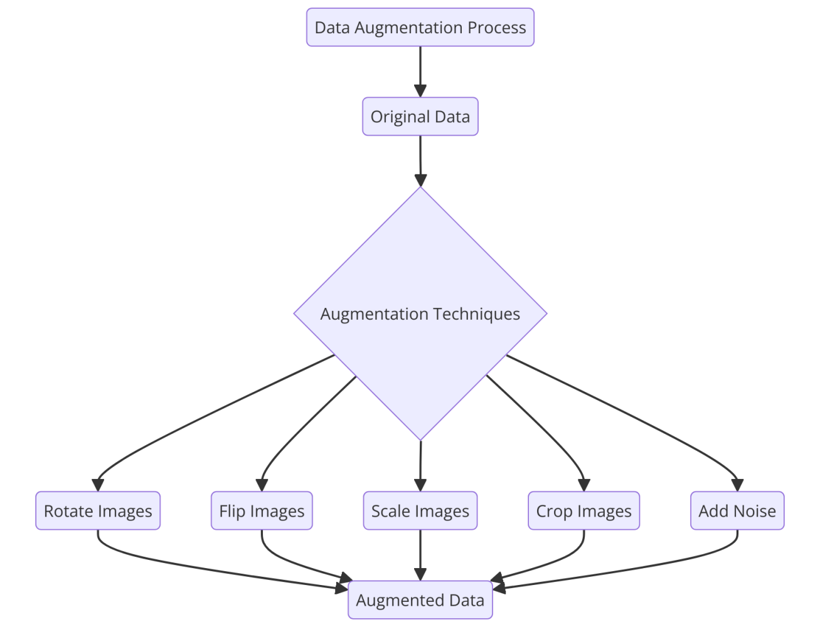

**What is Data Augmentation?**

Data augmentation is a technique used in machine learning, particularly in deep learning, to increase the diversity of the training dataset without actually collecting new data. This is achieved by applying various transformations and alterations to the existing data, creating new, slightly modified versions of the original data. The primary goal of data augmentation is to improve the generalization ability of machine learning models by exposing them to a wider range of variations, thereby reducing overfitting and enhancing model robustness

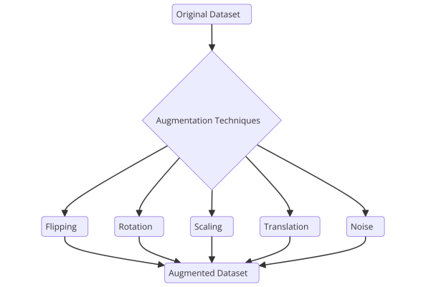

Data Augmentation involves creating new training examples from the existing data by applying various transformations. This not only increases the size of your dataset but also helps your model generalize better, leading to improved performance.

**Key Data Augmentation Techniques:**

**Geometric Transformations:**

* **Rotation:** Rotate images to generate new perspectives.
* **Scaling:** Adjust the size of images to enhance feature detection.
* **Translation:** Shift images horizontally or vertically to introduce variation.
* **Flipping:** Mirror images to create additional training data.

**Color Space Transformations:**

* **Brightness Adjustment:** Modify the brightness levels to simulate different lighting conditions.
* **Contrast Adjustment:** Vary the contrast to improve feature recognition.
* **Color Jittering:** Randomly change the hue, saturation, and value to increase diversity.

**Noise Injection:**

* **Gaussian Noise:** Add random noise to images to make models more resilient to real-world variations.
* **Salt and Pepper Noise:** Introduce sparsely occurring white and black pixels to mimic sensor noise.

**Advanced Techniques:**

* **Mixup:** Combine two images by blending their pixel values to create new training examples.
* **Cutout:** Randomly mask out sections of an image to force the model to focus on surrounding context.
* **Generative Adversarial Networks (GANs):** Use GANs to generate entirely new synthetic images.

**Example of Data Augmentation**

**Image Classification Example**

Consider a dataset used for training an image classification model. Let's say you have a limited number of images of different types of flowers, and you want to improve the model's performance by augmenting the dataset. Here are some common data augmentation techniques you can apply to images:

1. **Rotation:** Rotate the image by a certain angle (e.g., 15 degrees clockwise or counterclockwise).
2. **Flipping:** Flip the image horizontally or vertically.
3. **Scaling:** Resize the image by scaling up or down.
4. **Cropping:** Randomly crop a portion of the image.
5. **Translation:** Shift the image along the x or y axis.
6. **Adding Noise:** Introduce random noise to the image.
7. **Adjusting Brightness and Contrast:** Change the brightness or contrast of the image.
8. **Color Jitter:** Randomly change the colors in the image.

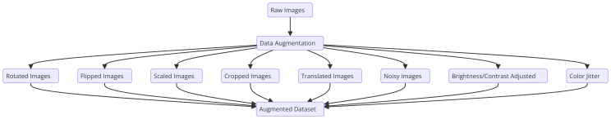Image Classification Example

**Importance of Data Augmentation**

1. **Improved Generalization**: By presenting the model with diverse variations of the data, it learns to generalize better to different conditions.
2. **Enhanced Robustness**: Models become more robust to variations and noise, improving their performance in real-world applications.
3. **Mitigation of Overfitting**: Augmentation helps prevent overfitting by increasing the effective size of the training dataset.

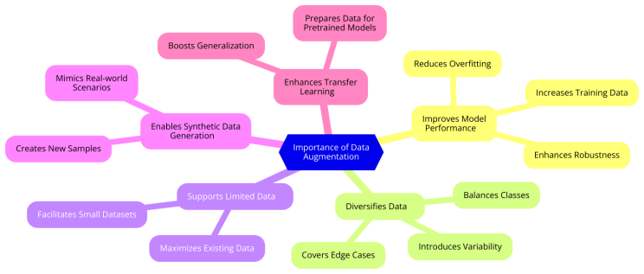Importance of Data Augmentation

**Importance of Data Augmentation**

**Improved Generalization**

Generalization refers to a model's ability to perform well on new, unseen data. When a model is trained on a dataset that includes a wide variety of data points, it learns to recognize underlying patterns that are consistent across different instances. Data augmentation achieves this by artificially creating new data points that are variations of the original dataset.

For example, consider a deep learning model designed to recognize handwritten digits. By augmenting the training dataset with rotated, scaled, and translated versions of the digits, the model learns that the digit '5' is still a '5' whether it is slightly tilted or shifted. This exposure to diverse variations helps the model to generalize better and recognize digits accurately even when they appear in slightly different forms in real-world scenarios.

**Enhanced Robustness**

Robustness in machine learning refers to a model's ability to maintain its performance when faced with variations or noise in the input data. In real-world applications, data is rarely clean and perfectly structured; it often contains noise, distortions, or unexpected variations.

Data augmentation helps enhance robustness by simulating these variations during the training process. For instance, in image recognition tasks, adding random noise, changing brightness, or applying slight blurs to the images during training can prepare the model to handle similar disturbances in real-world images. As a result, the model becomes more resilient and performs consistently well, even when the input data is not ideal.

**Mitigation of Overfitting**

Overfitting occurs when a model learns the training data too well, capturing noise and specific details that do not generalize to new data. This leads to high accuracy on the training data but poor performance on validation or test data. Overfitting is particularly problematic when the training dataset is small or lacks diversity.

Data augmentation helps mitigate overfitting by increasing the effective size and diversity of the training dataset. By introducing various transformations, such as flipping, rotating, or adding noise, the model is exposed to a broader range of examples. This forces the model to learn more general features rather than memorizing specific details of the training samples.

For example, in a scenario where a model is trained to classify images of cats and dogs, augmenting the dataset with variations in lighting, color, and orientation prevents the model from associating specific lighting conditions or angles with a particular class. Instead, the model learns to focus on more general characteristics, such as shapes and textures, which are more indicative of the classes and thus improves performance on new, unseen images.

**Examples of Data Augmentation in Practice**

1. **Image Classification**: In a dataset of car images, augmenting with rotations, flips, and brightness adjustments ensures the model can recognize cars in different orientations and lighting conditions, making it robust to real-world variations.
2. **Speech Recognition**: By adding background noise or varying the speed of audio samples, speech recognition models can become more resilient to different recording environments and speaking speeds, enhancing their accuracy in real-world applications.
3. **Natural Language Processing (NLP)**: Techniques like synonym replacement and back-translation (translating a text to another language and then back to the original language) help create diverse text data. This improves the model's ability to understand and process variations in sentence structure and vocabulary.

**Conclusion**

Data augmentation is a powerful technique to enhance the performance and robustness of deep learning models. By presenting the model with a diverse range of data variations, it learns to generalize better, becomes more resilient to noise and variations, and reduces the risk of overfitting. Whether dealing with images, text, or audio, incorporating data augmentation into the training process is a vital step towards building more effective and reliable machine learning models.

**Principle of data augmentation?**

Data augmentation is a technique used in machine learning, particularly in the field of computer vision and natural language processing, to increase the diversity of data available for training models without actually collecting new data. This is achieved by making minor alterations to existing data, creating new examples that help the model generalize better.

* Principle of Data Augmentation

1. **Enhance Data Diversity:**

- **Variation Introduction:** By applying various transformations to the original data, data augmentation increases the variety of data the model is exposed to, making it more robust and less prone to overfitting.

- **Simulating Real-world Variations:** It simulates the different variations the model might encounter in real-world scenarios, such as changes in lighting, orientation, noise, or other distortions.

2. **Increase Training Data:**

- **Artificial Data Generation:** Data augmentation generates new data from existing data, effectively increasing the size of the training dataset without the need for additional data collection.

- **Balanced Classes:** It can help in balancing classes in imbalanced datasets by generating more samples of underrepresented classes.

* Common Techniques

1. **Image Data Augmentation:**

- **Geometric Transformations:** Rotations, translations, scaling, and flipping.

- **Color Space Transformations:** Adjusting brightness, contrast, saturation, and hue.

- **Noise Injection:** Adding random noise to the images.

- **Cropping and Padding:** Randomly cropping parts of the image or padding with extra pixels.

- **Affine Transformations:** Shearing, stretching, and warping the images.

2. **Text Data Augmentation:**

- **Synonym Replacement:** Replacing words with their synonyms.

- **Random Insertion:** Adding random words at various positions.

- **Random Deletion:** Removing words at random.

- **Random Swap:** Swapping the positions of words randomly.

3. **Audio Data Augmentation:**

- **Time Stretching:** Changing the speed of the audio without affecting the pitch.

- **Pitch Shifting:** Changing the pitch of the audio without affecting the speed.

- **Background Noise:** Adding background noise to the audio.

- **Time Shifting:** Shifting the audio waveform in time.

* Benefits

1. **Improved Generalization:**

- Models trained with augmented data are better at generalizing to new, unseen data.

- It reduces the risk of overfitting to the training data.

2. **Reduced Data Collection Costs:**

- Reduces the need for large amounts of labeled data, which can be costly and time-consuming to collect.

3. **Enhanced Model Performance:**

- Typically leads to improvements in model accuracy and robustness, especially in tasks involving image and text data.

* Challenges

1. **Quality of Augmentation:**

- Poorly chosen augmentation techniques can introduce artifacts that might mislead the model.

- Balancing between too much and too little augmentation is crucial.

2. **Computational Overhead:**

- Some augmentation techniques can be computationally expensive and may slow down the training process.

Data augmentation is a powerful tool in the machine learning toolbox, allowing models to perform better with limited data and making them more robust to variations in the input data.

**What is the difference between data augmentation and preprocessing?**

Data augmentation and data preprocessing are both essential steps in the machine learning workflow, particularly in the context of preparing data for training models. However, they serve different purposes and are applied in different ways. Here’s a detailed explanation of each and their differences:

**Data Augmentation**

**Purpose:**

* Data augmentation is primarily used to artificially increase the size and variability of the training dataset. This helps in improving the generalization of the model and reducing overfitting.

**Techniques:**

* **Image Data:** Techniques include rotation, translation, flipping, scaling, cropping, adding noise, changing brightness, contrast, or color, and more.
* **Text Data:** Techniques include synonym replacement, random insertion, random swap, and random deletion, as well as back-translation (translating a sentence to another language and back).
* **Audio Data:** Techniques include changing pitch, speed, adding noise, and applying filters.

**Application:**

* Data augmentation is typically applied on-the-fly during the training process. This means the original data is dynamically augmented to generate new variations each time the model is trained.

**Example:**

* For an image classification task, an image of a cat might be rotated by 15 degrees, flipped horizontally, and have its brightness adjusted to create new training examples.

**Data Preprocessing**

**Purpose:**

* Data preprocessing involves cleaning and transforming raw data into a format suitable for model training. The main goal is to ensure that the data is in a consistent and usable state, removing any noise or errors.

**Techniques:**

* **Cleaning:** Handling missing values, removing duplicates, correcting errors, and outlier detection.
* **Transformation:** Normalization, standardization, scaling, encoding categorical variables, and feature extraction.
* **Integration:** Combining data from different sources, merging datasets, and ensuring consistent formats.
* **Reduction:** Dimensionality reduction, feature selection, and sampling.

**Application:**

* Data preprocessing is typically done before the training process. The raw data is transformed into a clean and usable format, which is then fed into the model for training.

**Example:**

* For a tabular dataset, missing values in a numerical column might be filled with the mean of that column, categorical columns might be converted into numerical format using one-hot encoding, and numerical features might be normalized to have a mean of 0 and a standard deviation of 1.

**Key Differences**

1. **Objective:**
2. **Timing:**
3. **Techniques and Operations:**
4. **Impact on Data:**

Understanding these differences is crucial for effectively preparing data for machine learning tasks and ensuring that models are trained on high-quality and diverse datasets.

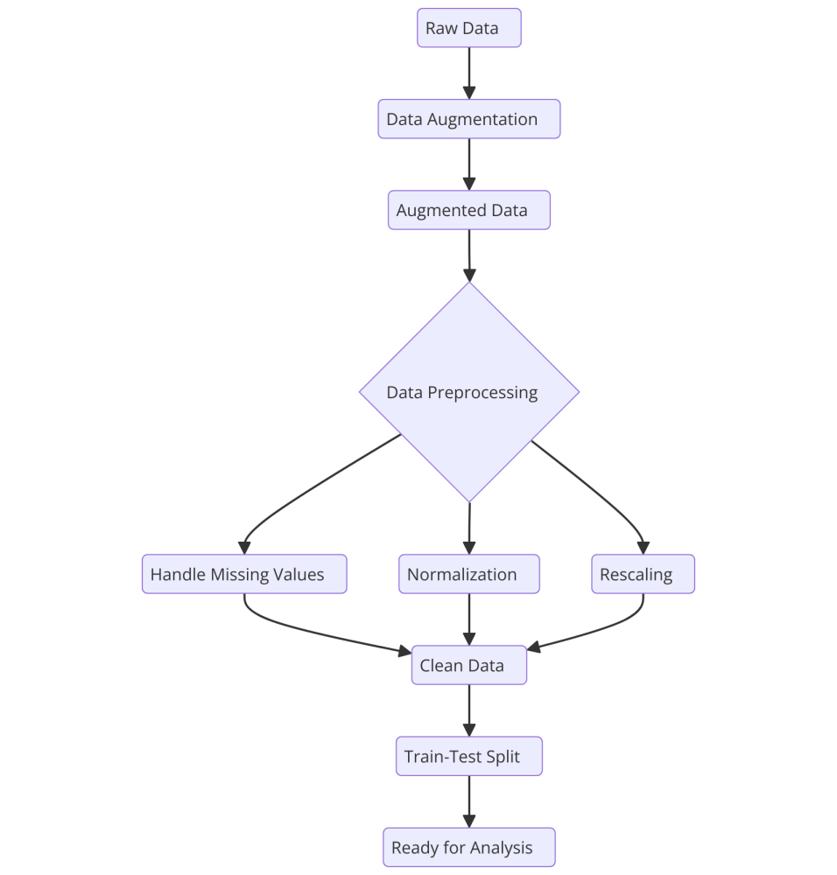data augmentation and preprocessing

**What is the difference between data augmentation and data enrichment?**

Data augmentation and data enrichment are both techniques used to improve datasets in the context of machine learning and data analysis. However, they have different goals, methods, and applications. Here's a detailed comparison of the two:

**Data Augmentation**

**Purpose:**

* Data augmentation is used to increase the size and variability of a dataset to improve the generalization ability of a machine learning model and reduce overfitting.

**Techniques:**

* **Image Data:** Techniques include rotation, translation, flipping, scaling, cropping, adding noise, changing brightness, contrast, or color, and more.
* **Text Data:** Techniques include synonym replacement, random insertion, random swap, and random deletion, as well as back-translation (translating a sentence to another language and back).
* **Audio Data:** Techniques include changing pitch, speed, adding noise, and applying filters.

**Application:**

* Applied during the training phase, often dynamically, to create new variations of existing data points on-the-fly.

**Example:**

* For an image classification task, an image of a cat might be rotated by 15 degrees, flipped horizontally, and have its brightness adjusted to create new training examples.

**Data Enrichment**

**Purpose:**

* Data enrichment aims to enhance the dataset by adding new information or context that is not originally present in the data. This additional information can improve the quality and comprehensiveness of the dataset, thereby enhancing the insights and performance of the machine learning model.

**Techniques:**

* **Adding External Data:** Integrating data from external sources, such as demographic data, geographic data, social media data, or other relevant datasets.
* **Feature Engineering:** Creating new features from existing data that can provide additional predictive power or insights. This can include aggregations, ratios, and interactions between variables.
* **Appending Metadata:** Adding contextual information or metadata, such as timestamps, location data, or device information.

**Application:**

* Applied before the training phase as part of the data preprocessing pipeline. The enriched data is then used for model training and analysis.

**Example:**

* For a retail sales dataset, enriching the data might involve adding weather data for each sales transaction date, which could help the model understand how weather conditions affect sales.

**Key Differences**

1. **Objective:**
2. **Timing:**
3. **Techniques and Operations:**
4. **Impact on Data:**

**Summary**

* **Data Augmentation** is about creating more variations of your existing data to improve model robustness and prevent overfitting.
* **Data Enrichment** is about adding new, relevant information to your dataset to improve its quality and the insights you can derive from it.

Both techniques are crucial in different stages of the machine learning workflow and contribute to building more effective and accurate models.

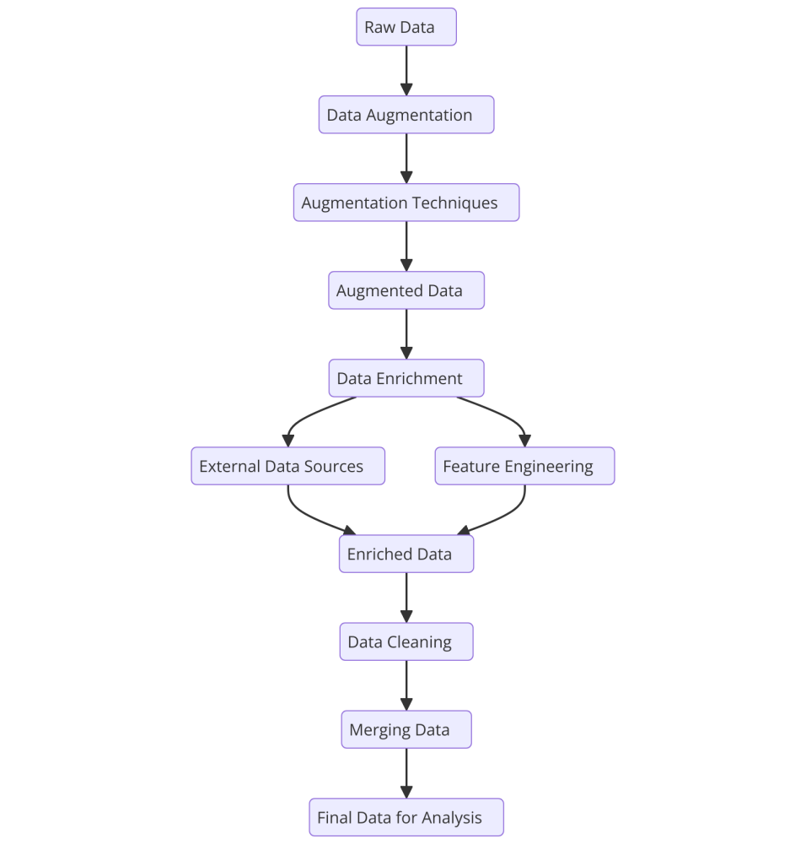data augmentation and data enrichment

**Common Data Augmentation Techniques**

1. **Geometric Transformations**: Include rotations, translations, scaling, and flipping. These techniques help models become invariant to changes in position, orientation, and size of the objects in images.
2. **Color Space Transformations**: Adjusting color properties to make the model robust to changes in lighting conditions.
3. **Noise Injection**: Adding random noise to images to make the model robust to noisy inputs.
4. **Cropping and Padding**: Randomly cropping parts of images and padding them to the original size to simulate partial occlusions.
5. **Affine Transformations**: Combining scaling, rotation, and translation for complex transformations.
6. **Advanced Techniques**: Leveraging more sophisticated methods such as:

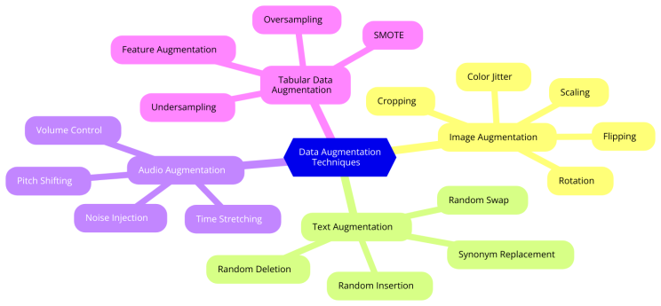Data Augmentation Techniques

**Common Data Augmentation Techniques**

**Geometric Transformations**

Geometric transformations involve altering the spatial properties of images. These techniques help models become invariant to changes in the position, orientation, and size of objects within the images, improving their ability to generalize across different scenarios.

1. **Rotation**: Rotating images by random angles helps the model recognize objects regardless of their orientation. For example, an image of a cat can be rotated by 15, 30, or even 90 degrees, and the model will learn to identify the cat irrespective of the angle.
2. **Translation**: Shifting images horizontally or vertically ensures that the model learns to recognize objects even if they are not perfectly centered. This is useful in scenarios where the position of the object within the frame varies.
3. **Scaling**: Zooming in or out of images changes the size of the objects within the frame. Scaling helps the model become size-invariant, meaning it can recognize objects of varying sizes.
4. **Flipping**: Horizontal and vertical flips can simulate the appearance of objects from different viewpoints. For instance, flipping an image of a dog horizontally helps the model learn that the dog is still the same even if its orientation changes.

**Color Space Transformations**

Color space transformations involve adjusting the color properties of images. These transformations make the model robust to changes in lighting conditions and color variations, which are common in real-world scenarios.

1. **Brightness Adjustment**: Randomly increasing or decreasing the brightness of images helps the model handle variations in lighting conditions.
2. **Contrast Adjustment**: Modifying the contrast of images can help the model focus on essential features regardless of the overall lighting differences.
3. **Saturation Adjustment**: Changing the intensity of colors can make the model robust to variations in color saturation, which might occur due to different camera settings or environmental conditions.
4. **Hue Adjustment**: Altering the hue of the images ensures that the model can recognize objects even if their colors change slightly due to lighting or other factors.

**Noise Injection**

Noise injection involves adding random noise to images to simulate real-world noise and make the model robust to such disturbances.

1. **Gaussian Noise**: Adding Gaussian-distributed noise to images helps the model learn to handle random variations that are common in real-world data.
2. **Salt-and-Pepper Noise**: This involves adding random pixels of maximum and minimum intensity to images, simulating noise often seen in low-quality images.

**Cropping and Padding**

Cropping and padding techniques modify the dimensions of the images to simulate partial occlusions and ensure that the model can recognize objects even if they are not fully visible.

1. **Random Cropping**: Extracting random portions of images ensures that the model learns to identify objects even if parts of them are missing.
2. **Random Padding**: Adding pixels around the image to change its size helps the model handle variations in the framing of objects.

**Affine Transformations**

Affine transformations combine multiple geometric transformations such as scaling, rotation, and translation to create complex alterations in the images.

1. **Shearing**: Slanting the image along a particular axis helps the model learn to recognize objects even if they are viewed from an angle.

By combining these transformations, affine transformations create diverse and realistic variations of the original images, enhancing the model's ability to generalize.

**Advanced Data Augmentation Techniques**

In addition to the basic transformations, there are more advanced techniques that can further improve the robustness and performance of deep learning models.

1. **Cutout**: Randomly masking out sections of the image simulates occlusions and helps the model learn to focus on the remaining visible parts.
2. **Mixup**: Combining two images and their labels in a linear fashion helps the model learn to interpolate between different classes.
3. **CutMix**: Combining patches of two images along with their corresponding labels ensures that the model can handle images composed of multiple objects.

**Conclusion**

Data augmentation is a critical technique for enhancing deep learning models by creating diverse variations of the training data. Geometric transformations, color space adjustments, noise injection, cropping, padding, and affine transformations all contribute to making models more robust and generalizable. By incorporating these techniques, practitioners can build more accurate and reliable models capable of performing well in real-world scenarios.

**Case Study: Data Augmentation in Action**

Provide an example of a deep learning project where data augmentation played a crucial role in achieving high performance. Describe the initial results without augmentation and the improved outcomes after applying various augmentation techniques.

**Tools and Libraries for Data Augmentation**

* **TensorFlow/Keras**: Built-in image preprocessing and augmentation functions.
* **PyTorch**: torchvision transforms for image data augmentation.
* **Albumentations**: A fast and flexible library for augmenting images and bounding boxes.
* **imgaug**: A library to augment images for machine learning experiments.

**Best Practices for Data Augmentation**

1. **Start Simple**: Begin with basic augmentations and gradually incorporate more complex techniques.
2. **Evaluate Impact**: Continuously evaluate the impact of each augmentation technique on model performance.
3. **Use Validation**: Validate the augmented dataset to ensure it does not introduce unrealistic artifacts.
4. **Balance Augmentation**: Avoid over-augmenting, which can lead to noise and reduce model performance.

**Best Practices for Data Augmentation**

Implementing data augmentation effectively requires a strategic approach to ensure that the benefits outweigh any potential drawbacks. Here are some best practices to consider:

**Start Simple**

Begin with basic augmentations and gradually incorporate more complex techniques. This helps you understand the impact of each augmentation method on your model's performance.

1. **Basic Transformations**: Start with simple transformations like rotations, flips, and scaling.
2. **Incremental Complexity**: Gradually add more complex augmentations such as color adjustments, noise injection, and affine transformations as you observe the effects of the initial augmentations.

**Evaluate Impact**

Continuously evaluate the impact of each augmentation technique on model performance. This ensures that the augmentations are beneficial and not degrading the model's accuracy.

1. **Controlled Experiments**: Apply one augmentation at a time and observe changes in validation accuracy and loss.
2. **Performance Metrics**: Use appropriate metrics (e.g., accuracy, precision, recall) to assess the impact of augmentations.

**Use Validation**

Validate the augmented dataset to ensure it does not introduce unrealistic artifacts that could mislead the model during training.

1. **Visual Inspection**: Regularly visualize augmented images to ensure they still represent realistic examples.
2. **Validation Set**: Use a separate validation set that has not been augmented to monitor model performance on real, unaltered data.

**Balance Augmentation**

Avoid over-augmenting, which can lead to noise and reduce model performance. Striking the right balance between augmentation and original data is crucial.

1. **Augmentation Ratio**: Maintain a balance between the number of augmented and original samples in your training dataset.
2. **Diversity**: Ensure that augmentations do not dominate the dataset, leading to a loss of diversity and potential overfitting to augmented patterns.

**Additional Best Practices**

**Randomization**

Introduce randomness in augmentations to prevent the model from learning augmentation-specific patterns.

1. **Random Parameters**: Use random parameters within reasonable ranges for transformations (e.g., random rotation angles).
2. **Random Combinations**: Apply random combinations of augmentations to each image to increase variability.

**Realistic Augmentations**

Focus on augmentations that simulate real-world variations. Unrealistic transformations can confuse the model and degrade performance.

1. **Domain Knowledge**: Leverage domain knowledge to choose augmentations that reflect real-world conditions.
2. **Context Awareness**: Ensure augmentations are contextually appropriate (e.g., avoid extreme color changes for medical images).

**Augmentation for Specific Tasks**

Tailor augmentations to the specific requirements of your task or dataset.

1. **Task Relevance**: Use augmentations that enhance the model's ability to handle task-specific challenges (e.g., brightness changes for outdoor images).
2. **Dataset Characteristics**: Consider the characteristics of your dataset when selecting augmentations (e.g., text data vs. image data).

Effective data augmentation can significantly enhance the performance and robustness of deep learning models. By following best practices—starting simple, evaluating impact, validating augmented data, and balancing augmentation—you can maximize the benefits of this technique. Incorporating randomness, ensuring realistic augmentations, and tailoring techniques to specific tasks further ensure that your model is well-prepared to handle real-world variations.

Data augmentation is a vital technique in the toolkit of deep learning practitioners. By creatively transforming existing data, we can build more robust and accurate models capable of performing well in diverse real-world scenarios. Embrace data augmentation to unlock the full potential of your deep learning projects.

**Our Data Augmentation Services at [InbuiltData](https://in.linkedin.com/company/inbuiltdata?trk=article-ssr-frontend-pulse_little-mention" \t "_blank)**

At InbuiltData, we offer a wide range of data augmentation services tailored to your specific deep learning needs:

* **Customized Augmentation Pipelines:** We design and implement augmentation strategies specific to your dataset and model requirements.
* **Automated Augmentation Tools:** Leverage our state-of-the-art tools to seamlessly integrate augmentation into your workflow.
* **Performance Optimization:** Our experts fine-tune augmented datasets to maximize your model's performance and minimize overfitting.
* **Consultation and Support:** Get personalized advice and support from our team to enhance your deep learning projects.
* **Data Preprocessing and Cleaning:** Ensure your data is in the best shape possible before augmentation.
* **Synthetic Data Generation:** Use advanced techniques like GANs to create high-quality synthetic data for training.

**Why Choose [InbuiltData](https://in.linkedin.com/company/inbuiltdata?trk=article-ssr-frontend-pulse_little-mention" \t "_blank) ?**

🔹 **Expertise:** Our team of seasoned professionals brings years of experience in deep learning and data augmentation.

🔹 **Innovation:** We stay ahead of the curve by continuously exploring and implementing the latest techniques.

🔹 **Tailored Solutions:** Every project is unique, and so are our solutions. We customize our services to fit your specific needs.

🔹 **Results-Driven:** We focus on delivering tangible improvements in your model's performance.